**Technical Skills Assessment**

**Data Analyst**

**Recommended Time for Test: 180 minutes**

Import the following dataset, stored in a SQL file (test.sql). **Showing the structure of the ‘TEZ loan’ database:**

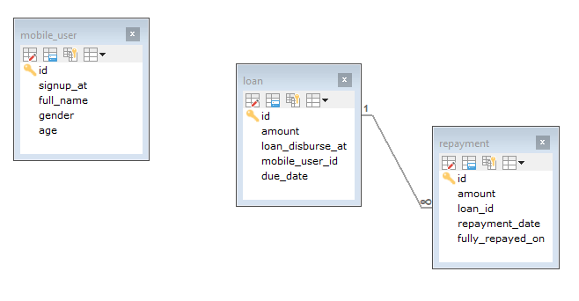

1

∞

There are three tables:

* 1. mobile_user: Information of the user who signs up with the TEZ service.
  2. loan: Every loan disbursed, link with the user who disbursed the loan.
  3. repayment: Every partial repayment, related to the loan.

**Complete All Task:**

**Task 1**

By using the data available generates the following output table:

|  |  |  |  |  |  |
| --- | --- | --- | --- | --- | --- |
| **User Id** | **Signup date** | **loan Id** | **Disbursement at** | **Due date** | **Day passed due** |

**Task 2**

Generates the output which shows the total number of signup counts for daily basis:

i.e

|  |  |
| --- | --- |
| **Signup date** | **Numbers of signups** |
| 2018-05-31 00:00:00 | 26 |
| 2018-05-30 00:00:00 | 30 |
| 2018-05-29 00:00:00 | 37 |
| .  .  . | .  .  . |

**Task 3**

Show 3 most disbursed user id:

i.e

|  |  |
| --- | --- |
| **User Id ( Top 3 )** | **Number of disbursements** |
|  |  |
|  |  |
|  |  |

**Task 4**

Show total unique user activity for month of May 2019:

i.e

|  |  |
| --- | --- |
| **Activity Type** | **User(s) Count** |
| User Signups |  |
| Loan Disbursements |  |
| Repayments |  |

**Task 5**

Generate a csv file containing a time window matrix highlighting the number of signup made in each time cell as follows:

|  |  |  |  |
| --- | --- | --- | --- |
| Day/Time | 00:00 to 07:59 | 08:00 to 15:59 | 16:00 to 23:59 |
| Monday |  |  |  |
| Tuesday |  |  |  |
| Wednesday |  |  |  |
| Thursday |  |  |  |
| Friday |  |  |  |
| Saturday |  |  |  |
| Sunday |  |  |  |

- All time columns are in the 24 hour time format

**- Provide you answer to these tasks in word document. Name this document ‘{YourName}_data_task’**